Weekly Construction Progress Report – Week 26
Harrow Bay Offshore Wind · 22 Jun – 28 Jun 2026
Elena Márquez · 29 June 2026 · HB-PM-RPT-2026-W26

1. Summary
1 monopile (HB-A10) was installed this week, bringing the total to 10 of 40. The foundation campaign is 2 piles behind the Rev 2 baseline (12 planned). Waiting on weather amounted to 4 hours.
Area | Status | Comment
Overall schedule | Amber | 10/40 monopiles vs. 12 planned
Foundations | Amber | TPs installed: 8
Offshore substation | Green | Jacket installed 27 Jun
Cables | Green | Manufacturing on schedule
HSE | Green | No incidents

2. Progress
Metric | This week | Cumulative | Plan (cum.) | Variance
Monopiles installed | 1 | 10 | 12 | -2
Transition pieces installed | 0 | 8 | – | –
Waiting on weather (h) | 4 | 203 | – | –
Persons on board (avg.) | 103 | – | – | –
Man-hours MV Sea Atlas | 8,492 | 98,298 | – | –
Lost time injuries | 0 | 0 | 0 | 0
Recordable injuries | 0 | 0 | – | –
Near misses reported | 0 | 3 | – | –
HSE observation cards | 20 | – | – | –

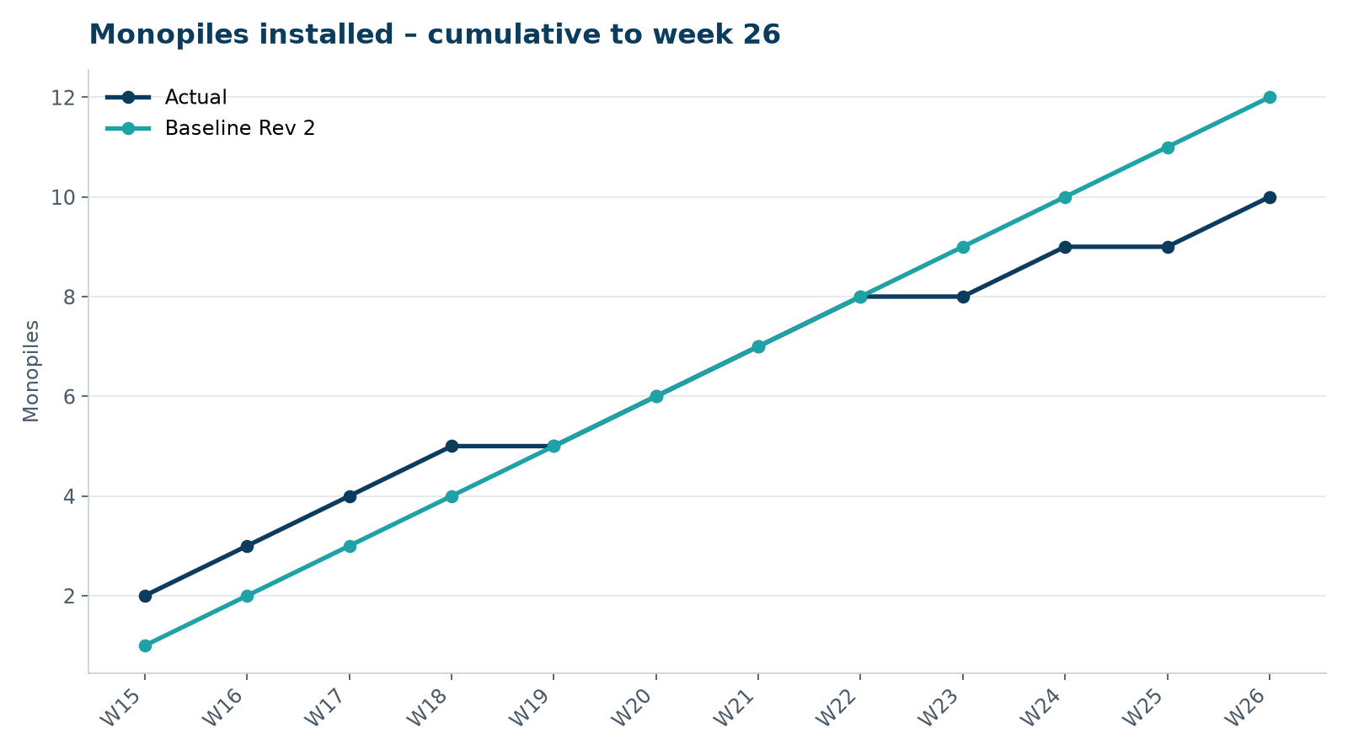
Figure 1 – Monopile installation progress, W15 to W26

3. Key activities this week
- HB-A10 installed on 24 June – the last pile before the July seasonal piling restriction.
- Offshore substation jacket installed on 27 June by the heavy-lift vessel; four pin piles driven with bubble curtain.
- Cumulative 10 of 40 monopiles against a baseline of 12.

4. Health and safety
No lost time injuries. 20 observation cards submitted; top theme: housekeeping on the main deck.

5. Environment
- HB-A10: peak 158.2 dB SEL at 750 m (compliant); harbour porpoise detected in the mitigation zone during the pre-piling search, soft start delayed by 20 min.

6. Issues and risks
- HB-RISK-001 weather: 4 h downtime this week.

7. Look-ahead next week
Transition pieces HB-A09/A10; demobilise piling spread for July.
Prepared by Project Controls (Gareth Lewis); approved by Elena Márquez. Distribution: project team, Steering Committee, Halden Turbine Systems, Lenders' Technical Adviser.

